

Department of Information Technology

IT0011: INTEGRATIVE PROGRAMMING AND TECHNOLOGIES

TW23

Final Project

Grade

Submitted by:

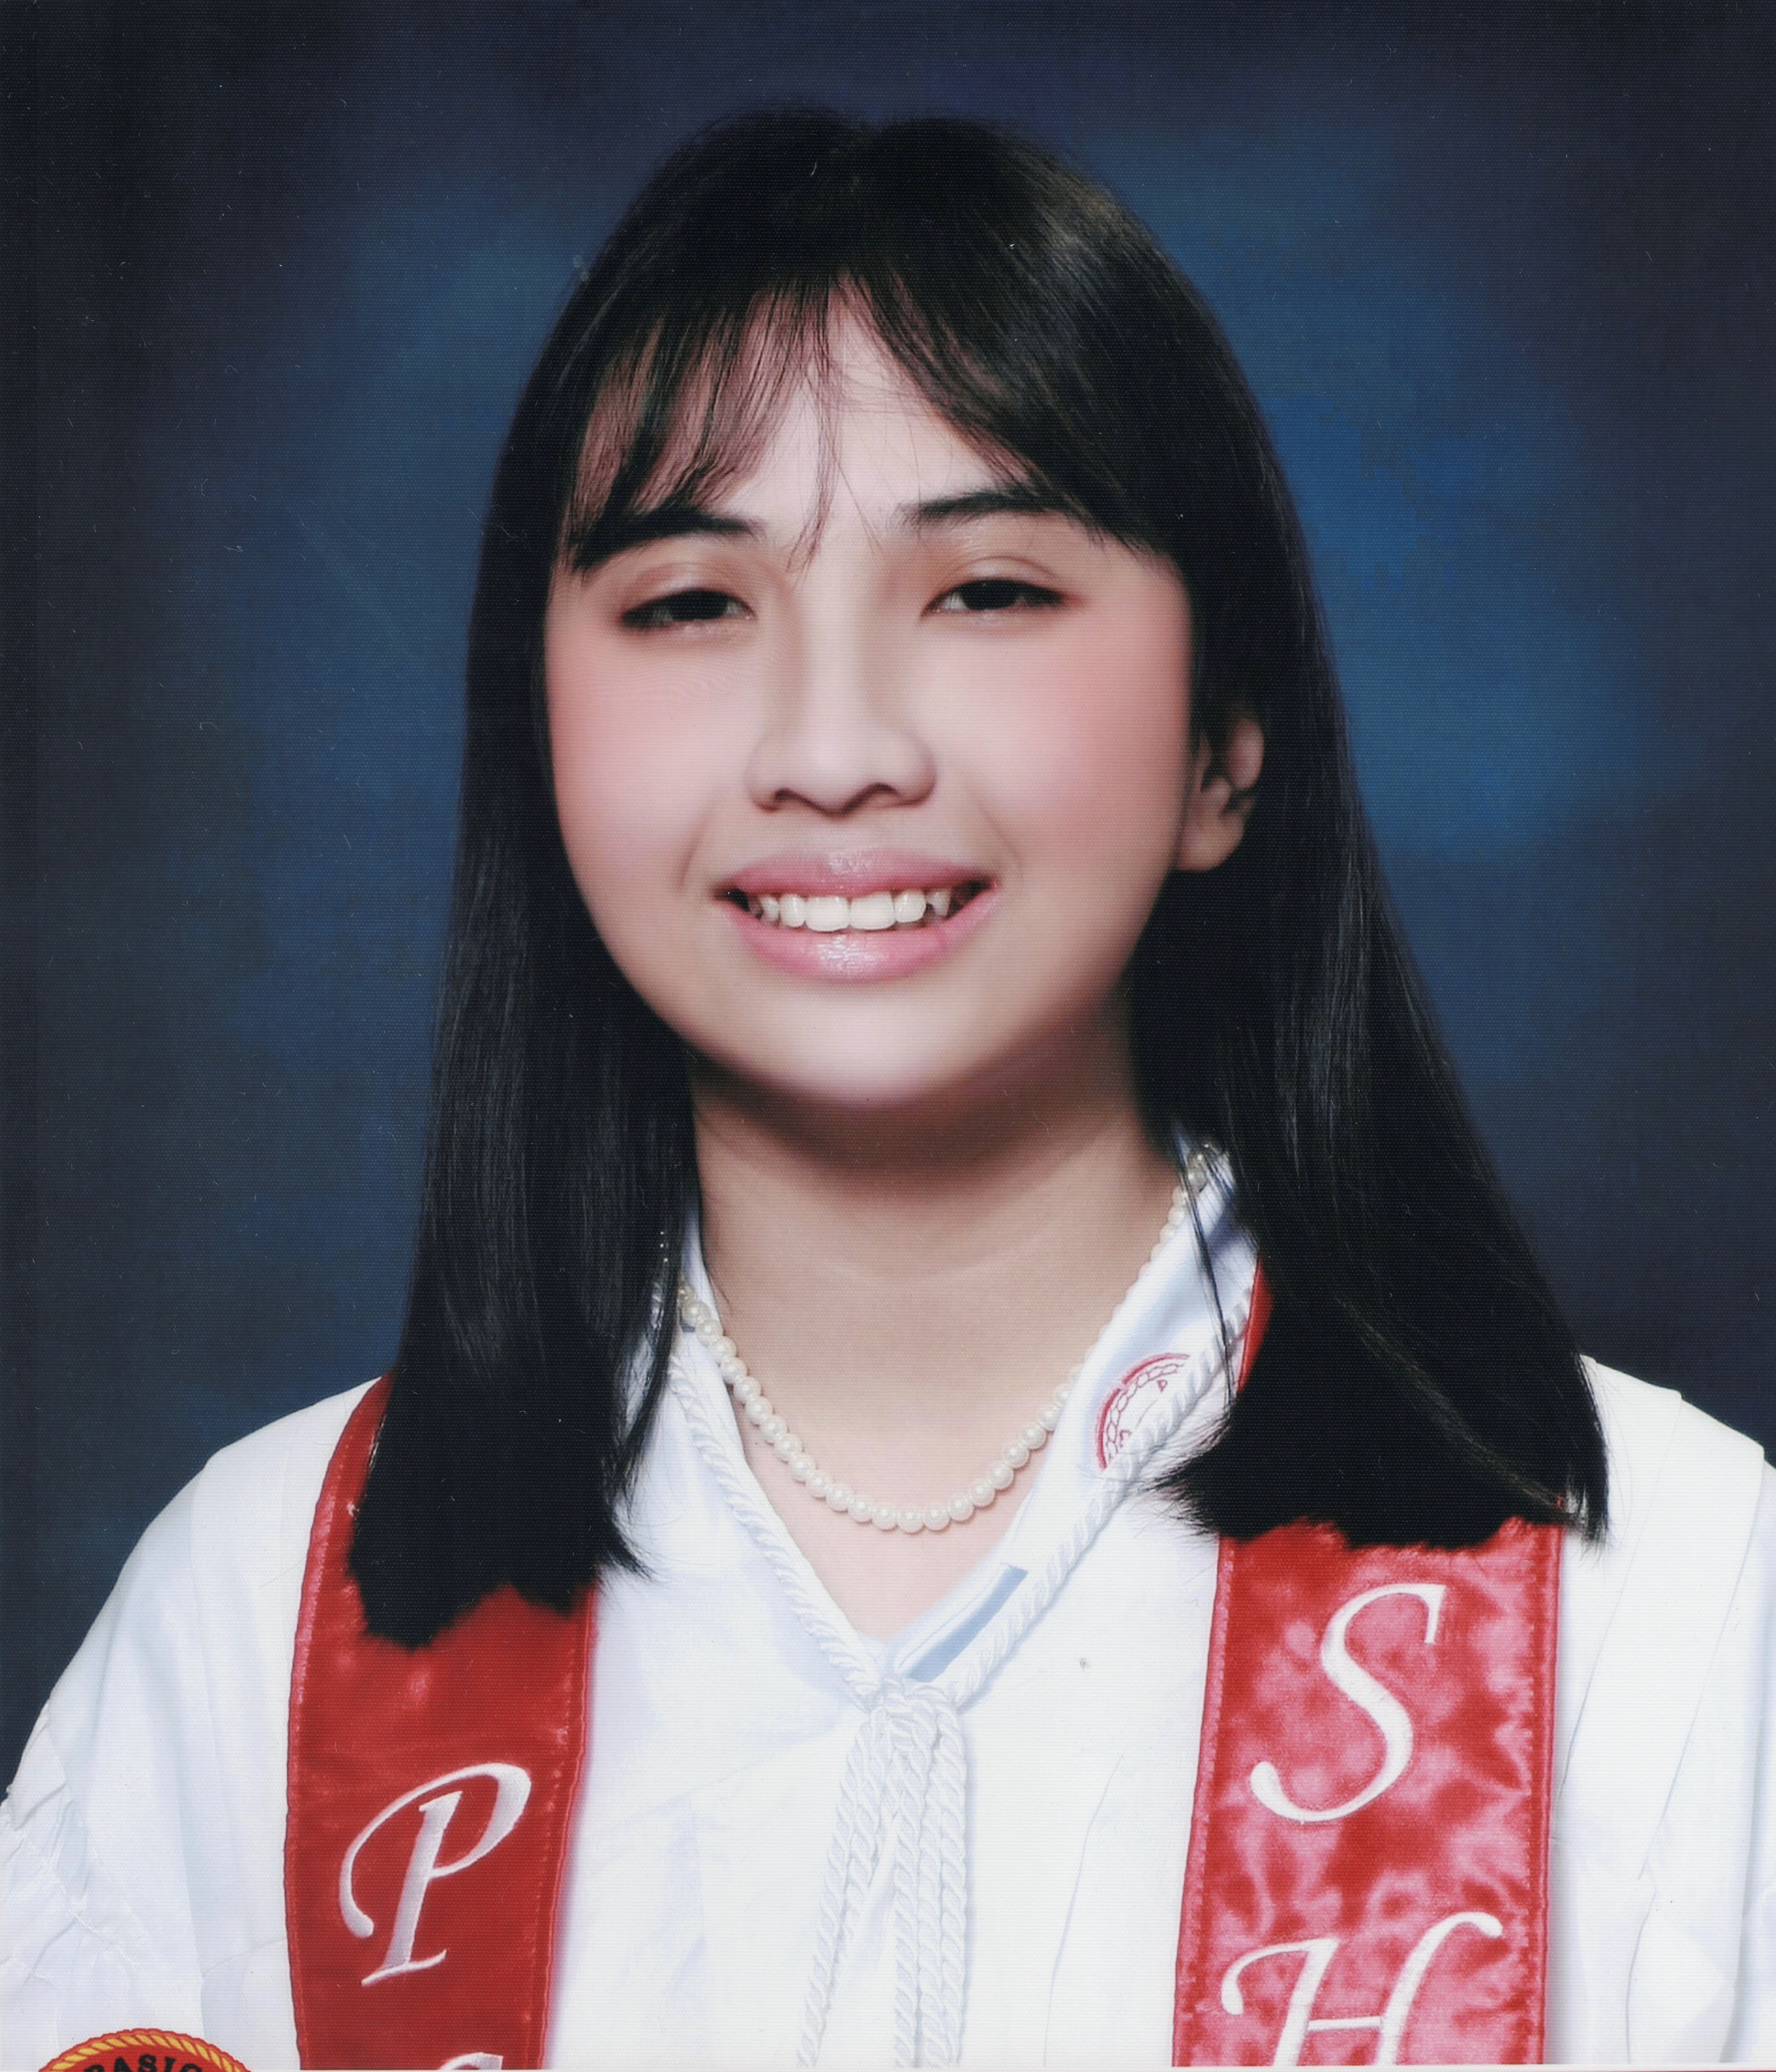Mag-Iba, Nhica J.

Hulip, Alessandra Lei G.

Hilario, Jannah B.

|  |
| --- |
| Submitted to:  Mr. Joseph Calleja |

**DOCUMENT CONTENTS:**

1. **INTRODUCTION**

The project is a Graphical User Interface (GUI)-based Record Management System designed to store and manage records efficiently. The system provides an intuitive interface that allows users to perform essential operations such as signing up, viewing all stored records, searching specific records, and exiting the application. The program is implemented in Python using Tkinter for the GUI, ensuring an interactive and user-friendly experience.

In developing the system, the developers applied fundamentals of Python programming, including variables, control structures, and loops, to handle user inputs and manage program flow. String and File Handling were implemented to store and retrieve data from a text file (records.txt), ensuring data persistence even after the program is closed. The program also utilizes collections, such as lists, to efficiently store and manipulate records. The project follows a modular approach using functions, allowing better code organization, reuse, and maintainability. Object-Oriented Programming (OOP) principles were incorporated to structure the code efficiently, improving scalability and readability.

The system features a menu-driven interface, enabling users to choose from different operations, including signing up, viewing all records, searching for a particular record, and exiting the application. During the sign-up process, users are required to provide essential details such as their first name, middle name, last name, birthday (formatted as YYYY-MM-DD), and gender (Male/Female). To ensure data integrity and prevent errors, the program incorporates exception handling, validating input fields, checking date formats, and handling file-related errors effectively.

Additionally, the system includes functionalities for viewing all stored records and searching for specific entries based on the user's first or last name. By implementing file handling, GUI development, and error management in Python, the project demonstrates an organized and user-friendly approach to managing personal records while maintaining efficiency and accuracy.

1. **OBJECTIVES**

* **To Develop a User-Friendly Record Management System:** Create a computer program that enables effective record management through a user-friendly graphical user interface (GUI) to make it accessible and straightforward to use for those with less technical knowledge.
* **To Establish Data Persistence:** Make sure that all the records are stored in a file-based system (records.txt) so that data is saved even when the program is closed and then opened.
* **To Provide Key Capabilities: Allow users to carry out the following actions:**
  + **Registration:** Add new accounts using data like first name, middle name, surname, date of birth, and gender.
  + **Show all records** in a readable and understandable format.
  + **Search Records:** Provide users with the ability to lookup specific records by name, first name, last name, or full name.
  + **Exit:** Provide a way to exit the program gracefully.
* **To Validate and Preserve Data Integrity:** Implement input validation procedures to ensure that all fields are properly filled, dates are in YYYY-MM-DD format, and gender is either "Male" or "Female."
* **To Use Exception Handling:** Deal with potential errors elegantly, like file not found, invalid input, or permission errors, so that the program runs normally without crashing.
* **For Facilitating Collaborative Interaction Between Team Members:** Split the project into individual modular pieces (e.g., file handling, user registration functions, viewing records, search functions, and graphical user interface integration) to enable smooth working among team members.
* **To Demonstrate the Use of Python Programming Concepts:** Demonstrate the usage of Python fundamentals like file handling, exception, data structure (lists), and GUI development with tkinter.
* **To lay a groundwork for future advancement:** Design the software in an extensible and modifiable manner that will enable future features such as deleting, modifying, or importing the records into a database system.
* **To Offer a Complete and Functional Application:** Consolidate all the components into one cohesive, yet functional program, that fulfills provided constraints and provides one well-integrated user experience.

1. **PROGRAM SCREEN SHOTS**

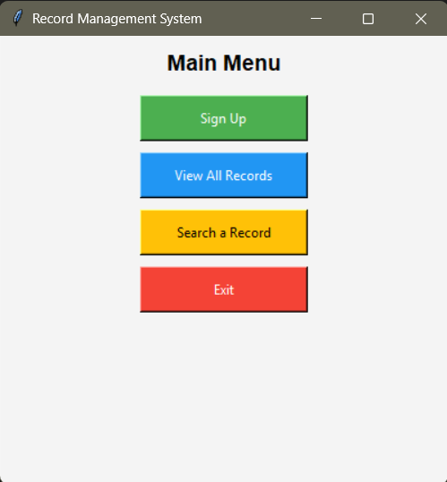

**Figure 1. Main Menu**

Figure 1 shows the main menu the user can choose from. It is the first thing the user will see and is designed using Tkinter for a user-friendly graphical format that makes the program straightforward and understandable for users with minimal technical knowledge. It presents users with different options varying from registering a new account, viewing all the existing records, searching for a specific record, and exiting the application. The menu is designed to be simple and easy to use so users can quickly find and access each function.

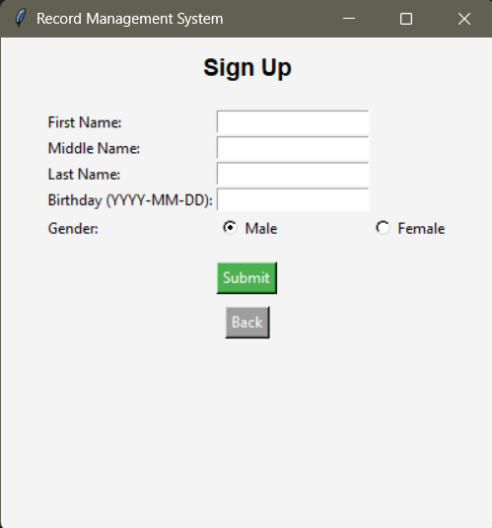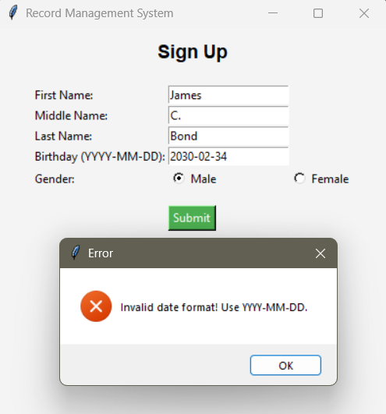

**Figure 2. Sign Up**

Figure 2 allows the users to register an account by providing their details such as their first name, middle name, surname, date of birth that must be provided with the format YYYY-MM-DD, and gender. Before saving the information into records.txt, the program first checks that each field is correctly formatted and not left empty. This validation ensures that only accurate and properly formatted records are stored to prevent errors in retrieving data.

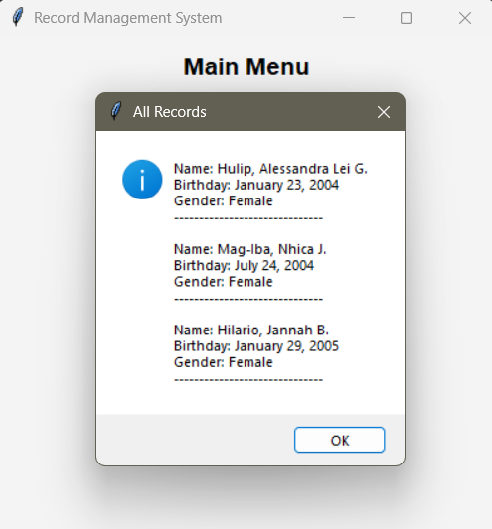

**Figure 3. View All Records**

Figure 3 shows the View All Records functionality wherein it displays all stored records in the text file. Each record includes the name, birthday, and gender of the individuals, formatted in a structured manner for easy readability. This feature ensures that users can efficiently retrieve and review existing data within the system.

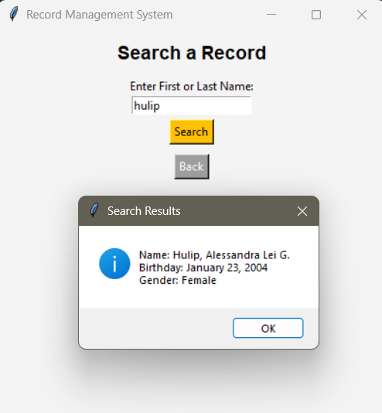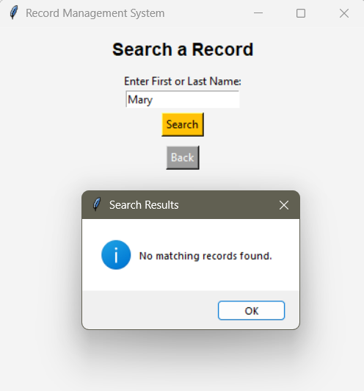

**Figure 4. Search Record**

Figure 4 illustrates the search functionality of the system, allowing users to look up a record using either the first or last name. If a matching record is found, it displays the full name, birthday, and gender. However, if no matching record exists in the file, the system prompts a message indicating that the record is not found.

1. **SOURCE CODE**

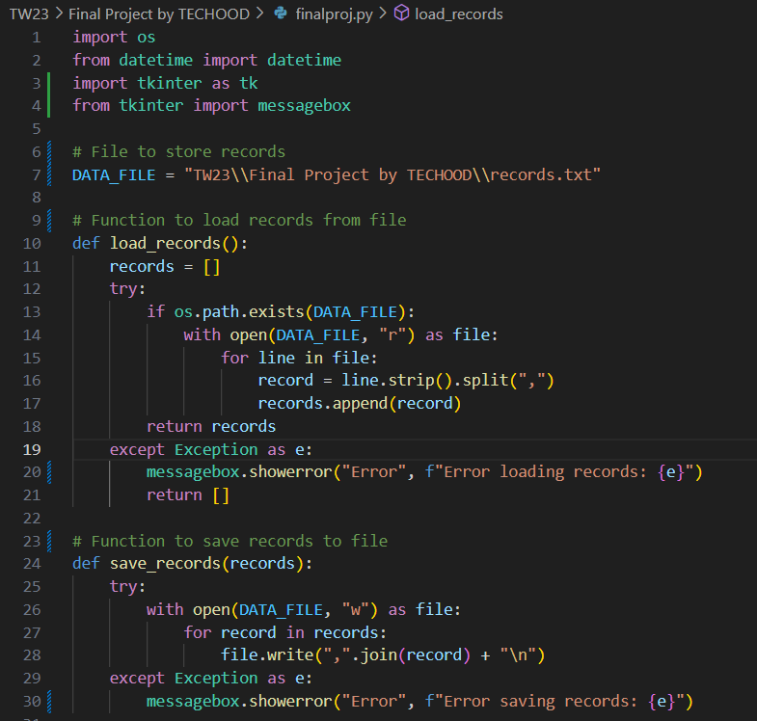 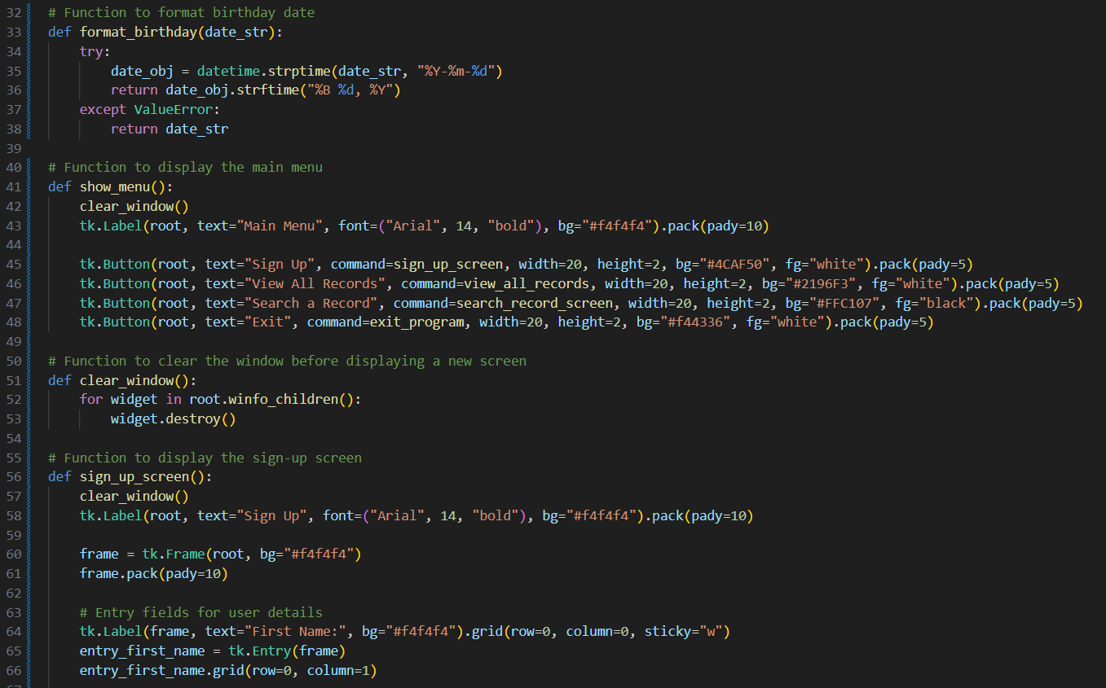 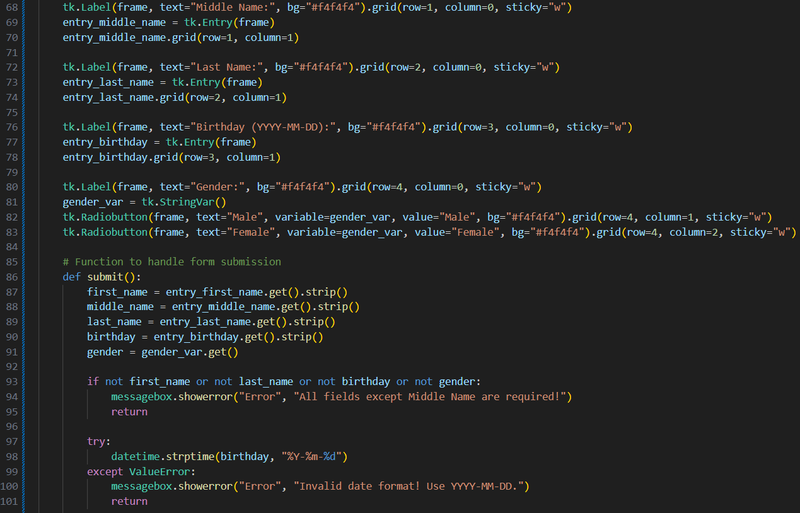 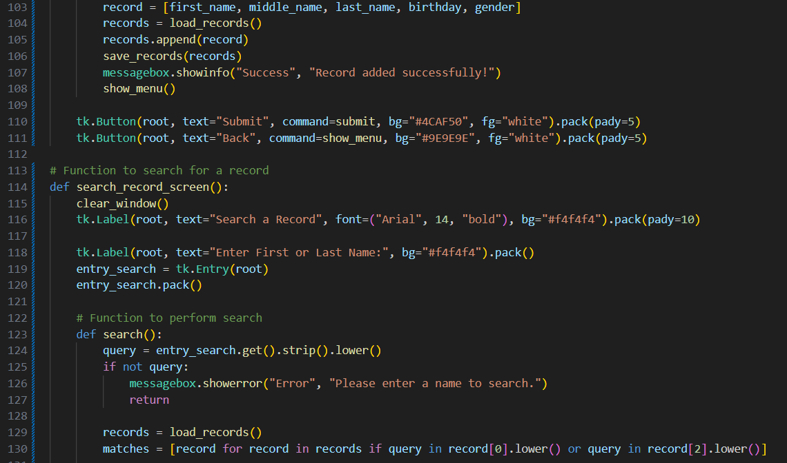 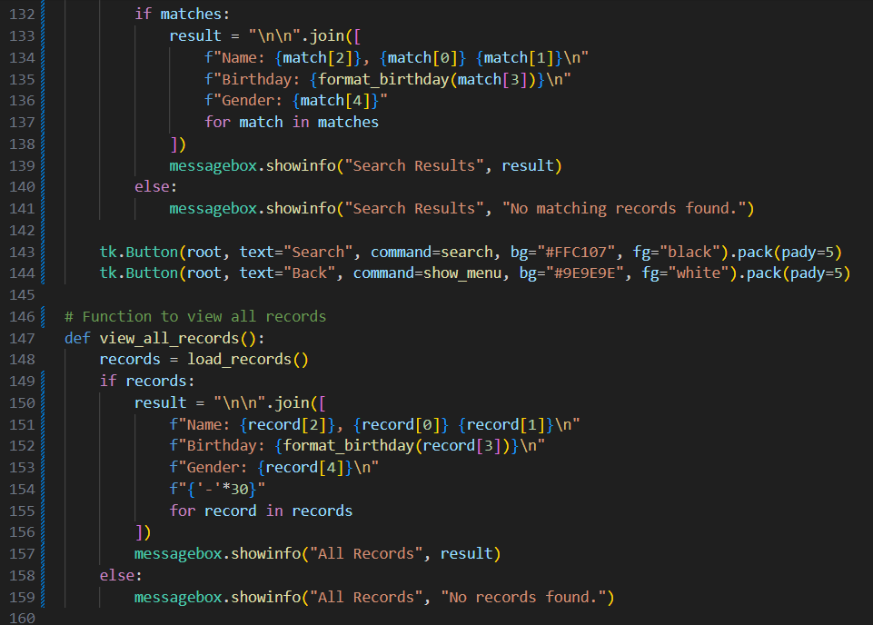 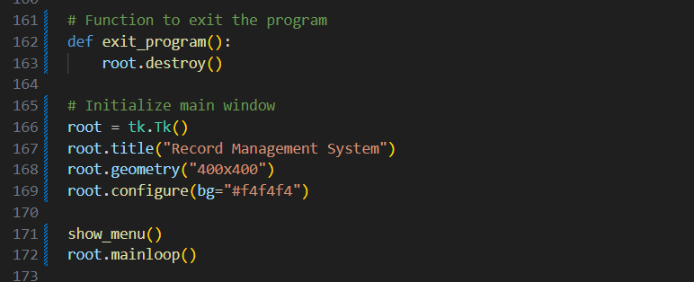

1. **SUMMARY AND DISCUSSION**

The Record Management System was developed using python and is integrated with a graphical user interface (GUI). The program has different functionalities that vary from registering an account, viewing all records, searching for a record, and exiting the application while making sure that all records are saved in a file named records.txt. It utilizes several Python libraries to enhance functionality, including Tkinter for the GUI, OS to check if records.txt exists before reading or writing data, Datetime to validate and format the date of birth (YYYY-MM-DD), and Tkinter.messagebox to display error messages and pop-up notifications.

To make the program easier to maintain, try-except blocks are used to handle potential errors, such as missing files, incorrect inputs, or permission issues. The program is structured with multiple functions to efficiently manage its features: show_menu() displays the main menu, sign_up_screen() handles new user registration, search_record_screen() allows users to search for specific records, view_all_records() displays all stored records, and format_birthday(date_str) ensures the date format is user-friendly.